Tourism Industry

Introduction
- Mauritius has forged itself a unique reputation over the past decades as an idyllic holiday destination with its year-round warm weather, stunning tropical scenery, and a delightful blend of culinary, cultural and historical experiences born from the union of the three continents – Asia, Europe and Africa.

- Tourism is a central pillar of the Mauritian economy and its sustainability is realised by valuing the exceptional island-wide natural, cultural and heritage endowments.

- The industry is poised to offer great growth and investment potential and has, over the years, become a leading tourist destination among international travellers.

Tourism Sector - Key Statistics (2019)
- GDP contribution of 9% and direct value added of some USD 1.1 billion
- Foreign earnings of USD 1.8 billion
- Employment of 77,000 people
- Tourist arrivals of 1.4 million
- 112 hotels in operation with 13,489 rooms
- Occupancy rate - 73%
- 31,024 bed places
Investment opportunities in the hospitality industry
• Tourist Accommodation - Hotels, Resorts, high-end villas, eco-Lodges
• Gaming resort, leisure & recreational facilities - Golf Course, Leisure & entertainment facilities, theme parks, dolphin watching, water Sports, hot air balloon, bowling alleys
• Adventure & Eco Tourism - adventure parks
• Transportation - yacht marina, catamaran, coastal ferry services
• MICE (Meetings, Incentives, Conferences and Exhibitions) facilities
• Wellness tourism – Medical facilities, Religious and spiritual operators

Key Drivers
- Target of 2 million tourists by 2030

- Strong presence of leading hotel brands & residences:
  - One&Only, Club Med, Accor, Shangri-La, Four Seasons, InterContinental, Hilton, Starwood, Radisson Blu, Maritim, Outrigger, Holiday Inn

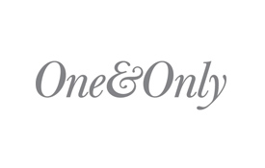
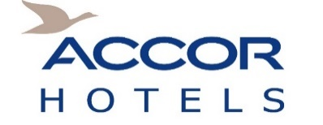

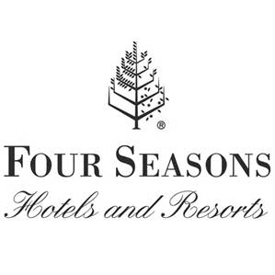
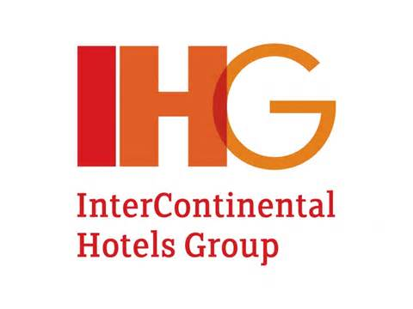
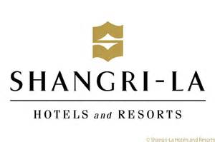

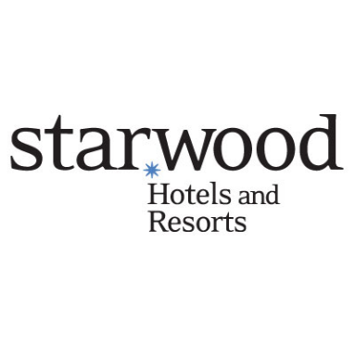
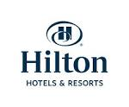

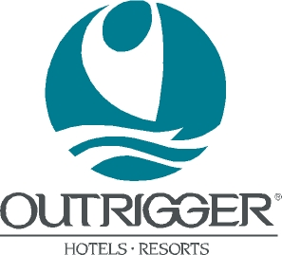

Hotels can be developed:

  - inland or on coastal land
  - on freehold land or leasehold land
  - within Smart Cities to benefit from the related incentives
  - under the Invest Hotel Scheme (IHS) which provide for sale of units. The IHS

    - serves as an alternative financing mechanism and allows sale of up to 80% of units to finance the construction of the hotel
    - allows unit owner to enter a lease back agreement with hotel developer in return for rental income
V
    - provides unit owner to stay up to 180 days in any period of 12 months
    - may allow unit owner to apply for residence permit on acquisition of a unit for a sum exceeding USD 375,000

Experienced labour force in the tourism sector
- Foreign labour is allowed across the industry
- 13% of the population is employed in this tourism sector
- Increase in income levels
- Growing domestic tourism

Subsector opportunities
Gaming resorts
Mauritius provides an enabling framework for hospitality and gaming consortia.
Gaming resorts comprising convention and exhibition facilities, themed attractions, entertainment and performance venues, casino gaming, recreation facilities, hotels and retail uses could be explored in the entertainment sector.
Diversified offerings allow gaming resorts to maintain decent hotel occupancy rates during seasonally slow leisure travel periods. Hospitality and gaming consortia offer the opportunity to create an industry that will meet the needs of the growing tourism industry.
Amusement parks
Amusement parks are some of the most popular tourist attractions throughout the world. With the increasing number of tourist arrivals, innovation is necessary for a constant rejuvenation of the existing tourist attractions.
New tourist attractions such as amusement parks with rides, roller coasters and water rides, animal parks, zoos, safari, adventure parks, 3D and interactive animation parks, film attraction parks, aquarium and marine parks can be developed in the island.
Leisure activities
The topography and the panoramic scenery of the mountains across the island offer a unique environment for leisure activities such as hiking, parasailing and paragliding. Since the island is surrounded by a coral fringing reef, snorkelling, scuba diving and submarine activities could be developed to explore the existing diversity of marine life. Divers can come face to face with dolphins, sharks, barracudas, eagle rays and an innumerable amount of fish. Further on, the south-western part of the island offers world class spots for surfing, wind and kite surfing

